**Process Description:**

Textile processing begins with bales of cotton. Cotton is purchased depending on the HVI (High Volume Instrument) Data provided by the USDA (United States Department of Agriculture). HVI Data provides information on the physical properties of cotton such as length, strength, uniformity, color, trash content, micronaire etc. Within bale variability, between bale variability and cotton mixing in mills forms a complex interaction among fiber properties, product characteristics, and process parameters through incorrect utilization by the textile industries. The cotton bales are subject to several different processes before the actual yarn formation. There are two factors that define textile processing. First is the size and quality of the desired yarn. Second is the ultimate end-use specifications for the product that is to be made from yarn. The process flow diagram of the yarn manufacturing is represented in Figure 2.0 on next page.

Cotton bales are not processed one at a time. They are processed in groups ranging from six to 100 bales, depending upon the opening and blending system. The laydown process is crucial for eliminating fiber variation found between individual bales. Selecting the bales for each laydown is critical because the average fiber properties for all bales in a laydown should be the same as the average of the previous one as well as the others to follow. Computer programs select and track the bale for production.

After bale selection, the bales are brought into a preparation area, and the straps and covering material are removed. To let bales acclimate to atmospheric moisture (expand and relax from compression effect), they are transferred to a staging area (or blow room). The blow room temperature is important. If it is too dry, the fibers will be weak and brittle. This will cause yarn breakage in the process. Also, the fibers may generate static electricity as they flow over metal surfaces making difficult to control fiber production. Too much moisture, on the other hand, will reduce the cleaning efficiency and will produce poor yarn quality. The relative humidity variation ranges from 55% to 65%. The selected bales should be held in the staging area for at least 24 hours before the opening and blending processes.



Figure 2.0 Textile Mill Process Flow Diagram (Yarn Production).

Opening process removes a group of fibers from each bale in the laydown and conveys them to a blending and cleaning machine as it is shown in Figure 2.1. Blending is simply mixing the fibers by a layering and tumbling action inside a large metal box. Heavy objects and pieces of wire or metal are removed at this stage of cleaning.

Cleaning equipment is designed to remove trash, dust, and other impurities. The first cleaner is usually placed immediately following the opening machine. As the fibers move through the machine in a spiral motion, fibers are further opened and pre-blended. For additional cleaning, the fibers are removed pneumatically where they are collected and formed into an even bat form. Here combing action takes place to remove more trash. At the end of the cleaning approximately 1.5% loss per weight processed takes place as salable waste on open fiber weight.

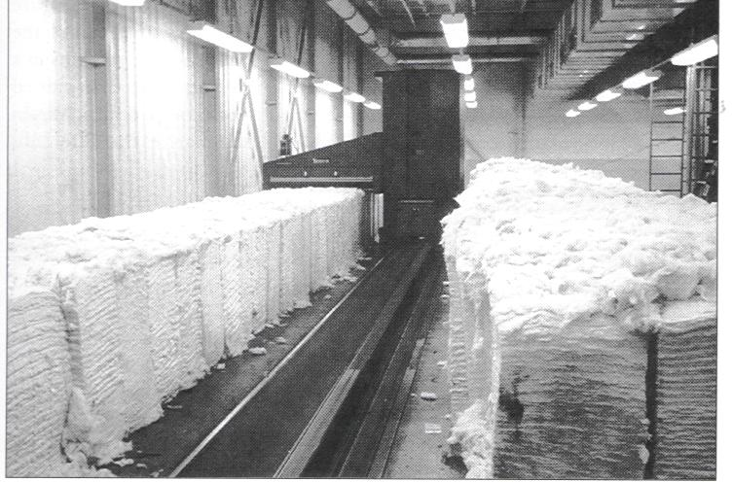

Figure 2.1 Opening Process (Elsasser, 1997).

The carding process is basically fiber alignment, cleaning, and forming into sliver as it is shown in Figure 2.2. At the end of the carding process nep reduction, short fiber reduction, and decrease in trash content is obtained. Carding machines process cotton at a slow rate as low as 45 kg/h (100 lb/h). In order to match the input from the opening, cleaning, and blending operations, several carding machines are necessary in the mill system. Thick or thin places on the sliver will result in uneven yarn. This is why fiber mass control is crucial at the carding process. Here approximately 4% loss per weight comes about as salable waste. Fiber cost is half of the total cost of a textile mill. Therefore, the carding process can be very costly, and is quality sensitive.

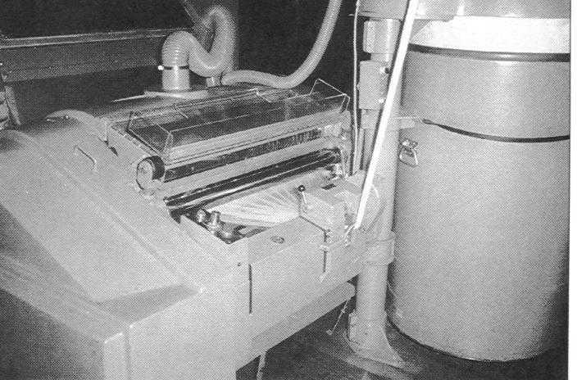

Figure 2.2 Carding Process (Elsasser, 1997).

Drawing process blends, straightens, and levels the slivers. Usually six or more slivers from carding machines are pulled through the drawing process at the same time. This way slivers from different carding machines are blended and mixed. Figure 2.3 demonstrates this process in a textile mill factory. Maintaining the evenness of the sliver and producing the proper weight per unit length required are important functions of this process. In the drawing machine, also the distance of the rolls is crucial for the process. If the distance of the rolls kept too close, some fibers may be gripped at both ends. This will cause some rolls to run faster than the previous set; therefore, fiber breakage may occur. If the distance of the rolls is too far apart, there will be too many fibers uncontrolled between the rolls. This will lead to producing uneven places in the sliver (drafting waves), and later on it will produce defected yarns. At the drawing process the waste produced is approximately 0.25% per weight, and it is considered as reworkable. However, for the rework there will be labor and overhead costs.

Combing is required for high quality yarn products. For this process slivers are run through the machine called a lapper to form lap from several slivers. By the end of combing more short fibers are removed, and fibers are more straighten and blended. Maintaining laps weigh at 1050 grains per yard is important. The waste after the lap formation is approximately 0.25% per weight, and it is considered as reworkable and salable.

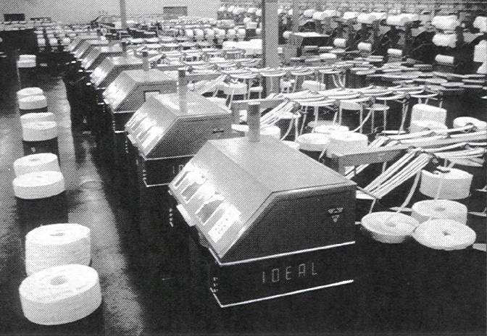

Figure 2.3 Drawing Process (Elsasser, 1997).

The final drawing process produces about 0.10% per weight reworkable waste. After final drawing the yarn spinning process takes place. Spinning type is determined by the desired properties of the yarn product and the required properties of the fiber to be processed. Table 2.0 lists the fiber properties that each spinning system requires (Hequet, 2004).

Table 2.0 Spinning Systems by the Importance of Fiber Properties.



If the end product is expected to be the strongest, finest, and softest yarn, ring spinning is performed. Roving is preparatory stage for ring spinning process (Figure 2.4). Slivers are twisted little bit and wounded on long bobbins to fit on the spinning machines. Roving waste is about 0.15% per weight and reworkable. At the spinning process, drafting rolls draw the fibers from the roving bobbins down to size required for the yarn. Then the yarn is wrapped around the bobbins for further processing. Ring spinning is the slowest and the most expensive spinning method due to additional processes; roving and winding. The winding operation is processed to supply adequate length of yarn to the warping operation which requires yarn that is uniform and free from all yarn imperfections as few as practically feasible. At the end of spinning process 1% per weight salable waste is produced and 0.5% of this waste is coming from the winding process.

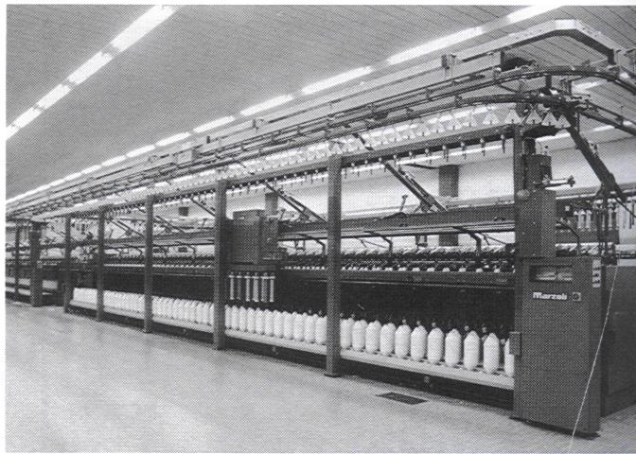

Figure 2.4 Roving Process with automatic doffing feature (McCreight et al. 1997).

Rotor spinning produces weaker yarns than ring spinning. The yarn count range is limited (few types of yarns). The fiber is formed into yarn by means of twisting with “s” rotating rotor. Rotor spinning has a high production capability. Because there are no additional steps to production, the cost is low compared to ring spinning. Figure 2.5 shows a rotor spinning process in a textile mill factory.

Air-Jet spinning is for very high production rate and a wide range of yarn sizes. The sliver is drafted to the required size with the conventional drafting system and then passed through two or more air jet nozzles. High pressure of air increases the strength of the yarn and adds additional friction where reduces slippage. Only problem with this system would be that it requires clean, strong fibers with uniform in length. Also, combed cotton is usually required for best performance (McCreight et al. 1997).

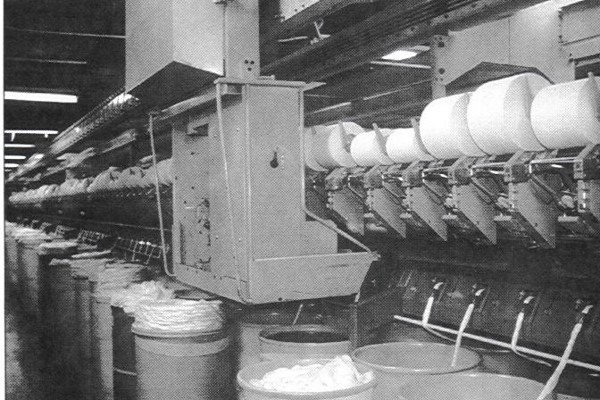

Figure 2.5 Rotor Spinning Process (McCreight et al. 1997).

### **Fiber Properties**

Through out the textile mill process the fiber characteristics alter the internal relations over time. Some of the fiber characteristics are moisture content, fiber fineness, maturity, fiber length, and fiber strength (Mogahzy et al., 2001). Moisture content of cotton is the relative amount of water in the surrounding air. In textile processing, very high humidity may cause fiber clinging and fiber lapping around rollers and other machine parts that this will lead to machine stops and uneven sliver. Low humidity may cause static electricity problems and increase short fiber content and neps. Controlling the moisture content can diminish end-breakage.

Fiber fineness is the measurement of the fiber diameter or thickness. For optimum spinning performance, the number of fibers per yarn cross-section is the criteria, and this is why fiber fineness is important fiber characteristic. Below certain number of fibers per cross-section can cause frequent end-breakages and increase the difficulty of spinning process. Fine fibers will produce more fibers per fiber strand. This means stronger yarn and better yarn uniformity is needed (McCreight et al. 1997).

Cotton fiber maturity directly related with nep formation, weak yarns, non-uniform surface appearance, and white speck. Some of these problems can be eliminated by proper blending and fiber selection techniques (McCreight et al. 1997).

Fiber length determines the type of spinning, then level of quality and the market value of the end product. Short and medium length produce coarse yarn when long fiber length made into fine yarns. Less than 0.5 inch length fiber can not be spun proficiently. In other words, below this value fibers can not be converted into yarns. Different fiber lengths require dissimilar adjustments of opening and cleaning equipment (McCreight et al. 1997).

Fiber strength depends on the degree of orientation of the fibers along fiber axis. It is the measure of breaking elongation. Low fiber elongation cause increasing force of drafting and perform poor spinning. High elongation spun at lower rotor speeds on rotor spinning results in better weaving performance (McCreight et al. 1997).

### **Data Description**

The data you have is to see how well the cleaning process was done before the yarn formation. You have 6 lines of production you are looking at. First quality check is the bale level at the opening process (Bale line1, Bale line2,….). Second quality check is done after cleaning process on each line separately (Mat1.1, Mat2.1....). Third quality check is done after sliver formation which is the stage before yarn formation (SL1.1,…,SL2.1,SL2.2,….,SL3.1….). Fiber properties provided;

|  |  |
| --- | --- |
| SFC (w)% | Short fiber content is defined as percent by weight of fibers of 0.5 inches or less |
| UQL (w) inch | upper quartile length by weight in inches |
| Dust (cnt/g) | Dust count per gram |
| Trash (cnt/g) | Trash count per gram |
| Nep (cnt/g) | Nep count per gram |

The objective is to be able to clean the cotton from dust and trash while eliminating short fibers and neps. Also, you do not want to create a harsh cleaning process too because this can get rid of more trash but it can produce more short fibers and neps.

### **Project Description**

There is no right or wrong answer. I would like to see how you can utilize the quality control charts to see what is going on with the process in general. I expect to see a MS Word report with your facts. Copy and paste all your control charts to your report. There is no page limitation.